Lettuce growth days

This project investigates how different environmental factors affect the growth rate of lettuce over a 44 day period
The analysis is based on a single plant sample (Plant ID 1) from a total of 70 for analysis. As a result, the findings reflect trends that were observed in this sample and they do not reflect the growth rate of all lettuce as a whole.

Methodology
Exploratory data analysis was conducted to identify the relationships and trends between environmental factors and lettuce growth. A pivot table was used to aggregate the cleaned and standardised data, enabling calculation of weekly growth rates and comparison across variables such as Temperature, Humidity, TDS value and pH.
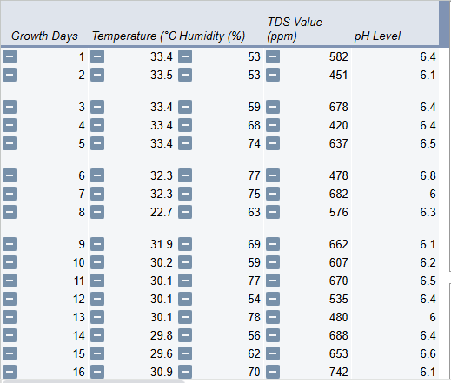
A pivot table was created to aggregate the relevant data for analysis which summarise the weekly growth rates and the corresponding environmental conditions such as pH and temperature. This ensures that the dataset is consistent and ready for visualisation and
statistical analysis.

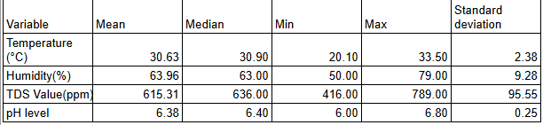
pH
The average pH level during the 44 day period was 6.38 with a standard deviation of 0.25, indicating stable conditions. The standard deviation being 0.25 means that the pH did not fluctuate a lot over time and values below pH 7 are slightly acidic, making lettuce grow best in this range to neutral soil / water.

Temperature
The average temperature over the 44 day period was 30.63°C with a standard deviation of 2.38°C. This indicates that temperature conditions were moderately stable, providing suitable conditions for lettuce growth with some variation.

Humidity
Optimal lettuce conditions are between 50% - 70% humidity. The average humidity over the 44 day period was 63.96% with a standard deviation of 9.28%. This indicates that humidity levels fluctuated day to day, but the humidity conditions remained suitable for lettuce growth.

Growth days vs Temperature
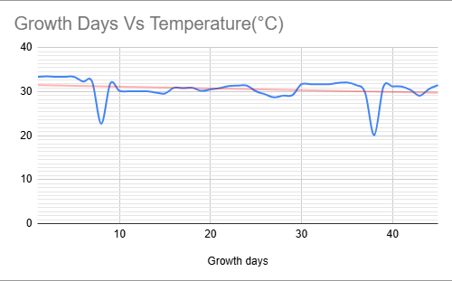
Figure 1
As shown in figure 1, the red trend line shows that temperature generally decreases slightly over the 44 day period with occasional days experiencing larger dips.
This downward trend coincides with the plant’s growth rate, suggesting that while temperatures remained mostly within the suitable range for lettuce growth, the variability on certain days may have temporarily affected the growth rate,
Overall, the moderately stable temperature conditions, as reflected in the average of 30.63°C, and a standard deviation of 2.38°C provided an environment stable enough for consistent growth, despite the fluctuations.

Temperate vs Humidity
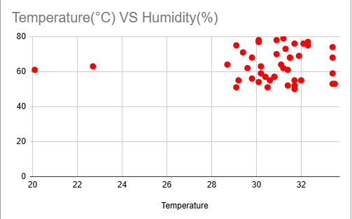
Figure 2
Figure 2 shows a scatter graph of temperature vs humidity over the 44 day period. The graph suggests that humidity tends to be slightly higher on days with higher temperatures. While the sample size is limited, this visual indicates a positive relationship between temperature and humidity during the observation period.
This observed trend complements the analysis of average temperature and
humidity, providing context for understanding environmental conditions that may influence growth patterns.

TDS Value vs pH level
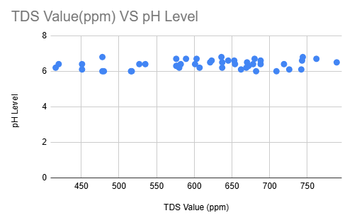
Figure 3
Figure 3 shows that pH levels remained relatively stable between 6 and 7, while TDS ranged from approximately 550ppm to 700ppm, indicating that variations in TDS did not substantially affect pH within the observed range.

Summary insight
Overall, the analysis indicates that the environmental conditions were generally stable and conducive to lettuce growth. The combination of moderately stable temperature, suitable humidity and consistent pH supported steady growth patterns in the sample plant throughout the observation period

Conclusion
The study demonstrates that careful monitoring of environmental factors can provide insights into lettuce growth trends. Even with minor fluctuations in temperature and humidity, stable pH and moderately stable environmental conditions supported consistent growth rate.

This approach highlights how data analysis can inform agricultural decisions and optimise growth conditions

